Brendan Harrington

Computer Science Theory Project 1

4.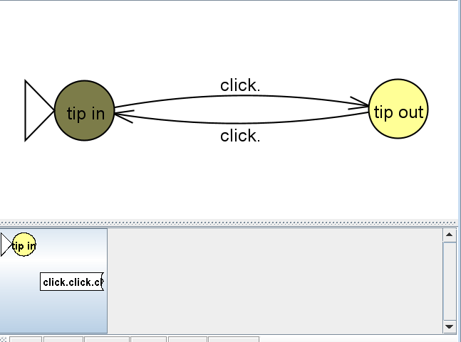 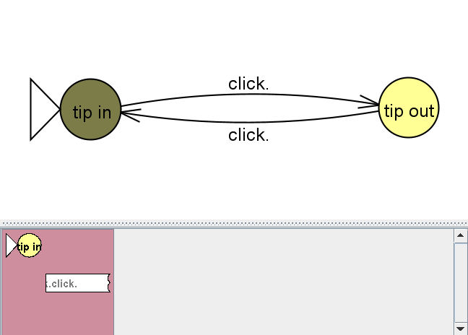

The input click.click.click.click went through the states and ended on the initial state. It only ends after the last command of click. is entered.

5.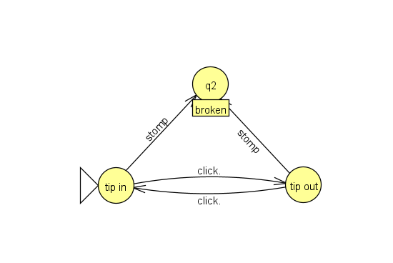

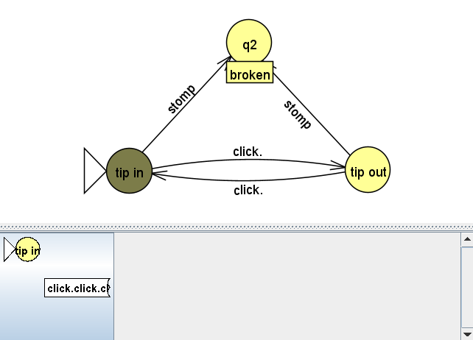

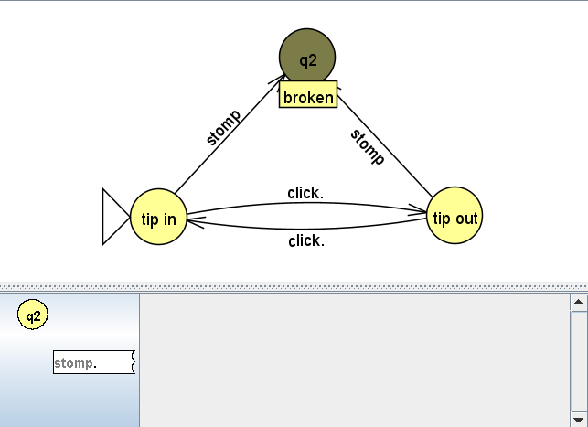

The DFA of a pen is now a NFA because not every state handles every transition. By introducing the new state without the click transition we changed the DFA to an NFA

6. When inputting click.click.click.stomp there was no issue traversing the NFA with all inputs, however when taking the click.click.click.stomp.click input the NFA was unable to complete the last click as there was no transition off of the broken state.

**Part 2:**

1. 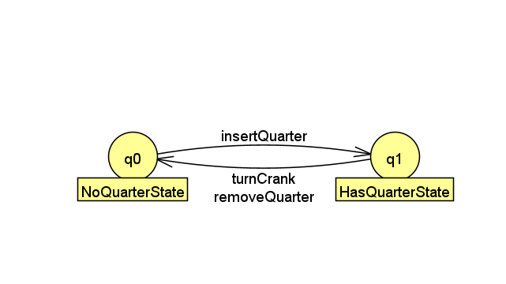 This is the NFA that represents the gumball machine. When in the noQuarterState the insertQuarter transition leads to the hasQuarterState, and when in the hasQuarterState the transitions turnCrank and removeQuarter lead to the noQuarterState

**Part 3:**

The Diagram that I came up with for the game is:

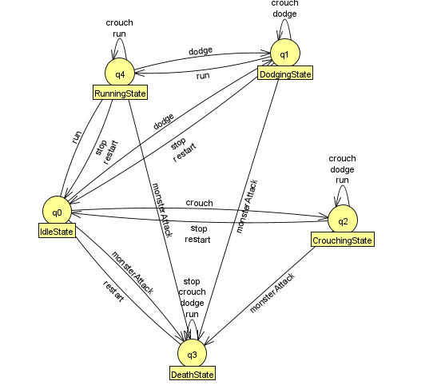

This has 5 states of:

* RunningState
* DeathState
* IdleState
* DodgingState
* CrouchingState

And the possible transitions are:

* Crouch
* Run
* Dodge
* Stop
* Restart
* monsterAttack

Each state has its own restrictions and only certain transitions allow for state changes